Note: We have highlighted all the changes in the revised manuscript with a yellow background.
From Scientific Literature to Alloy Discovery: A Corpus–Topic–Document Framework for Copper Alloy Informatics
Zixuan Zhao¹, Zhikang Xie¹, Fei Tan¹, Peiyun Chen¹, Yanbin Jiang^{1*}, Tong Xie^{2,3*}, Wei Chen¹, Haoran Ouyang¹, Jing He¹,Wenqin Xu¹, Yanpeng Ye⁴, Guofu Xu¹, Byungju Lee^{5,6}, Zhou Li¹
1 School of Materials Science and Engineering, Central South University, Changsha, 410083, PR China.
2 School of Photovoltaic and Renewable Energy Engineering, University of New South Wales, Kensington, NSW, Australia.
3 Green Dynamics, Sydney, 2000, Australia.
4 Physical Sciences and Engineering Division, King Abdullah University of Science and Technology (KAUST), Thuwal 23955-6900, Saudi Arabia.
5 Department of Materials Science and Engineering, Korea University, Seoul, Republic of Korea
6 Nanoscience and Technology, KIST School, University of Science and Technology, Seoul, Republic of Korea.

* Corresponding authors: Yanbin Jiang ( jiangyanbin@tsinghua.org.cn ).
Tong Xie (tong.xie@unsw.edu.au).
Abstract：
High-quality Composition–Processing–Structure–Performance (CPSP) data infrastructures are essential for data-driven copper alloy discovery, yet relevant knowledge remains fragmented across textual descriptions, experimental tables, and graphical contents in scientific literature. To address this challenge, we propose a literature-centric Corpus-Topic-Document (CTD) framework transforming heterogeneous literature resources into machine-readable CPSP knowledge resources and machine learning (ML)-ready copper alloy databases. At the corpus level, semantic filtering is performed on 122,982 alloy-related publications, identifying 3,245 copper-alloy-relevant publications distributed across 457 semantic clusters. At the topic level, the filtered literature is organized into 7 interpretable thematic knowledge modules, revealing the semantic structure and temporal evolution of copper alloy research. At the document level, textual, tabular, and graphical information are reconstructed into machine-readable CPSP records through coordinated multi-modal processing. Using this framework, 9,284 high-quality CPSP data chains were reconstructed from full-text literature, with the best-performing model achieving token-level F1-scores above 0.90. Experimental validation of the optimized Cu–Ni–Si–Cr alloys achieved peak-aged properties of hardness 375 HV, tensile strength 1133 MPa , elongation ~8% , and conductivity 25.27 %IACS. Micro-structural characterization further confirmed the deformation-precipitation synergistic strengthening. The proposed framework establishes a hierarchical pathway from scientific literature to data-driven alloy discovery for artificial intelligence-enabled materials development.
Keywords: Copper alloy informatics; Corpus–Topic–Document framework; Literature knowledge utilization; Composition-Processing-Structure-Performance chain reconstruction; Large language models; Machine-learning-guided alloy design
Introduction:
In recent years, artificial intelligence-driven paradigms have profoundly transformed the research and development of metallic materials [1]. With the rapid advances in high-throughput computation, large language models (LLMs), and autonomous scientific discovery platforms, traditional trial-and-error-based materials development is gradually evolving toward data-driven and intelligent decision-making paradigms [2-4]. In this context, autonomous materials informatics systems capable of know-ledge acquisition, experimental planning, and performance optimization have become an important direction in advanced materials research. Among various metallic systems, high-performance copper alloys are widely used in integrated circuit lead frames, high-speed connectors, power electronics, new-energy transportation, and advanced manufacturing owing to their excellent electrical and thermal conductivity, corrosion resistance, and mechanical reliability. However, modern copper alloys are often required to simultaneously achieve high strength, high electrical conductivity, thermal stability, and long-term service reliability under harsh operating environments [5-6]. In particular, the relationships among composition, processing, micro-structural evolution, and performance in copper alloy systems are characterized by high dimensionality, strong nonlinearity, and complex Composition-Processing-Structure-Performance (CPSP) coupling. Therefore, data-driven copper alloy discovery requires literature-derived knowledge infrastructures capable of systematically organizing and utiliz-ing CPSP relationships across composition, processing, structure, and performance. [7-8].
However, extensive CPSP knowledge embedded in the copper-alloy literature is rarely available in unified, structured, and machine-readable forms [9]. Instead, it is dispersed across textual descriptions, experimental tables, and graphical resources. Key information concerning alloy composition, heat treatment, deformation, microstructural evolution, strengthening mechanisms, and mechanical properties is often distributed among experimental procedures, Results and Discussion sections, figure captions, and mechanism analyses,where it is expressed using non-standardized and context-dependent terminology. Variations in table layouts, hierarchical headers, and annotation styles further hinder cross-publication data alignment and reconstruction [10]. Graphical resources, including microstructural images, diffraction patterns, and performance curves, provide essential evidence of phase transformation, structural evolution, and property responses. Nevertheless, the metallurgical meaning of a microstructural image cannot usually be inferred from visual appearance alone; phase identity, precipitate morphology, defect structures, and processing-induced microstructural changes are commonly established through the authors’ interpretations in the figure captions and accompanying discussion. Reliable structural-knowledge reconstruction therefore requires joint association of graphical evidence, textual interpretation, sample conditions, and experimental context. This fragmented, heterogeneous, and cross-modal distribution of CPSP knowledge makes its systematic organization, semantic alignment, and effective utilization a major challenge for copper-alloy informatics and intelligent materials design [11–12].
From this perspective, scientific literature can be regarded as a hierarchical semantic knowledge space organized at the corpus, topic, and document levels [13]. At the corpus level, large-scale alloy literature corpora constitute a global knowledge space spanning diverse alloy systems and research domains, enabling the identification of copper-alloy-relevant knowledge from the broader materials literature landscape [14-16]. At the topic level, the filtered copper alloy literature is organized into interpretable thematic knowledge modules, such as strengthening mechanisms, corrosion behavior, thermo-mechanical processing, and microstructural evolution, thereby revealing semantic organization and knowledge topology of copper alloy [20-23]. At the document level, individual publications contain fine-grained CPSP knowledge distributed across text, tables, and graphical contents, requiring comprehensive reconstruction of CPSP relationships from heterogeneous multi-modal sources. Such a hierarchical Corpus–Topic–Document framework provides a new paradigm for systematically reconstructing and utilizing scientific literature knowledge, thereby bridging fragmented publications and data-driven alloy discovery [24-25].
Building upon these challenges, this work proposes a Corpus–Topic–Document framework for literature-driven copper alloy informatics. The framework is established based on 122,982 alloy-related publications collected from major scientific publishers, including Elsevier, Springer Nature, and the Royal Society of Chemistry, and progressively transforms fragmented literature knowledge into actionable CPSP resources through corpus-level discovery, topic-level organization, and document-level reconstruction. At the corpus level, BERTopic integrated with UMAP is employed to perform global semantic filtering and identify copper-alloy-related semantic regions from the broader alloy literature landscape containing multiple metallic systems [10,15-16]. At the topic level, 3,245 copper-alloy-related publications are further organized using Latent Dirichlet Allocation (LDA) to construct statistically coherent thematic structures and interpretable semantic knowledge modules [26]. At the document level, fine-grained CPSP knowledge is reconstructed from semantically selected copper-alloy literature fragments through collaborative textual, tabular, and graphical extraction pipe-lines. Specifically, large language models are used to extract implicit metallurgical knowledge from natural language [27-29], schema-constrained reconstruction is used for high-fidelity table parsing [30], and vision-language models are applied to categorize and interpret graphical information, including microstructural images, diffraction patterns, and performance curves[31-32].Through cross-modal semantic alignment and unified knowledge representation, the proposed framework progressively transforms fragmented scientific literature into ML-ready CPSP knowledge resources for machine-learning-guided copper alloy design [33-35]. From reconstructed CPSP resources, 9,284 ML-ready high-quality data records were further selected for downstream validation, enabling multi-objective prediction and optimization of strength and electrical conductivity in representative Cu-Ni-Si-based and Cu-Cr-based alloy systems. Experimental validation further demonstrated the rapid design capability of the proposed framework for high-strength and high-conductivity copper alloys based on 950,400 composition-processing feature combinations, while microstructural characterization further revealed that the exceptional strength-conductivity synergy originated from the coupled interaction between retained deformation substructures and nano-scale Ni₂Si precipitates. More importantly, this work demon-strates a complete pathway from scientific literature to alloy discovery by integrating hierarchical literature knowledge organization, multi-modal CPSP reconstruction, machine learning, and experimental validation [11, 28-36].
Materials and Methods：
- Literature Corpus Construction
To support literature-driven copper alloy informatics, a large-scale alloy literature corpus was construc-ted using the Web of Science advanced search platform with the retrieval keywords “Alloy”, “Cu”, and “Copper”. Publications from 2000 to 2025 were systematically collected from major scientific publishers, including Elsevier, the Royal Society of Chemistry (RSC), and Springer Nature. Metadata, including titles, abstracts, keywords, and DOIs, were batch extracted, resulting in an initial corpus of 122,982 publications. The raw corpus was then subjected to standardized pre-processing procedures, including stopword removal, terminology normalization, lemmatization, and duplicate elimination, to facilitate subsequent semantic filtering and knowledge organization [25,27]. Semantic filtering was then employed to identify copper-alloy-relevant studies while excluding semantically irrelevant publications, such as archaeology-related copper studies and non-engineering materials literature [39].
- Corpus-Level Semantic Filtering Based on BERTopic-UMAP
At the corpus level, the BERTopic-UMAP framework was employed to characterize different research directions while preserving semantic neighborhood relationships across related topics to reduce information loss caused by overly rigid filtering [15]. By integrating pre-trained language models with topic modeling, BERTopic enables high-resolution semantic clustering and relevance identification within the literature embedding space. Specifically, each publication d_{i} was first mapped into a high-dimensional semantic embedding vector e_{i} using a pre-trained language model (e.g., Sentence-BERT):
$e_{i }= f_{embed}(d_{i})$ (2.1)
Subsequently, Uniform Manifold Approximation and Projection (UMAP) was applied for nonlinear dimensionality reduction of the high-dimensional embedding vectors, generating low-dimensional semantic representations u_{i}:
$u_{i }= f_{UMAP}(e_{i})$ (2.2)
UMAP compresses the high-dimensional semantic space while preserving local neighborhood structures, thereby enabling the emergence of well-defined semantic clusters in low-dimensional space. Based on these semantic embeddings, copper-alloy-relevant regions were identified from the broader alloy literature space, providing the corpus-level foundation for subsequent topic-level knowledge organization [16]. To further quantitatively validate corpus-level semantic filtering, a ground-truth (GT) benchmark of 500 publications was constructed for comparative evaluation. Three filtering strategies, including keyword-only retrieval, full-metadata lexical retrieval, and BERTopic–UMAP semantic filtering, were evaluated against the same GT labels using recall and F1-score. Detailed benchmark construction, annotation, and evaluation procedures are provided in Supplementary Note S5 and Supplementary Tables S5–S6.
- Topic-Level Knowledge Organization Based on Latent Dirichlet Allocation
Latent Dirichlet Allocation (LDA) is a classical probabilistic generative topic model, assuming each publication is generated from a mixture of multiple latent topics, while each topic corresponds to a probability distribution over vocabulary [26]. For a given document corpus, the joint probability distribution can be expressed as:
(2.3)

where ω denotes the observed word set, z represents topic assignments, θ and ϕ correspond to the document-topic and topic-word distributions, respectively, α and β are Dirichlet hyper-parameters.
In this study, LDA was employed to organize the filtered copper alloy literature into interpretable thematic knowledge modules. The optimal number of topics was determined using the topic coherence score, enabling identification of the major research themes and their semantic relationships within the copper-alloy domain. This process reveals topic-level knowledge distribution of copper alloy research and provides an organized semantic structure for subsequent document-level CPSP reconstruction and downstream alloy design.
- Validation of Multi-modal CPSP Reconstruction
A two-stage strategy combining automated validation and human-in-the-loop assessment was adopted to ensure the reliability of document-level CPSP reconstruction and establish the Ground-Truth (GT) benchmark. The established DualTrack-MatExtractor benchmark was further extended with copper-alloy-specific textual and tabular CPSP records and manually annotated scientific figures, resulting in 506 CPSP records with 2,737 annotated entities, 256 heterogeneous XML/HTML tables, and 372 scientific figures across nine categories [13, 17-18]. Based on the validated CPSP infrastructure, a stagewise prediction-error reduction analysis was further conducted to quantify the incremental contributions of physico-chemical features, CTD-derived metallurgical knowledge, and model optimization to predictive performance [19].
4.1 Automated validation
Candidate CPSP records generated by representative LLMs and VLMs under identical prompting strategies were first subjected to deterministic quality control against the original text, XML/HTML tables, figures, and captions. Structural integrity, contextual consistency, and numerical correspondence were automatically examined. Graphically extracted data were verified against figure captions, axis labels, units, calibrated coordinates, and numerical values, while reconstructed table records were checked against their original XML/HTML structures. Records with incomplete structures, contextual inconsistencies, unmatched values, or invalid source correspondence were flagged for subsequent expert review.
4.2 Human-in-the-loop validation and quantitative evaluation
Following the automated validation, candidate CPSP records were further reviewed by materials researchers and verified by senior domain experts against the original text, XML/HTML tables, figures, and captions. Discrepancies were resolved through expert adjudication, and only consensus annotations were incorporated into the Ground-Truth (GT) benchmark. The resulting benchmark comprised 506 CPSP records with 2,737 annotated entities, 256 heterogeneous XML/HTML tables, and 372 scientific figures across nine categories, covering composition, processing, structure, properties, strengthening mechanisms, and multi-modal reconstruction. Based on the established GT benchmark, multi-modal CPSP extraction performance was quantitatively evaluated using accuracy, precision, recall, F1-score, and BLEU score [37]. Accuracy, precision, recall, and F1-score are defined as follows:
$Accuracy= \frac{TP + TN}{TP + TN + FP + FN}$ (2.4)
$Precision= \frac{TP}{TP + FP}$ (2.5)
$Recall= \frac{TP}{TP + FN}$ (2.6)
$F1−score= \frac{2 × Precision × Recall}{Precision + Recall}$ (2.7)
Here, TP, TN, FP, and FN denote correctly identified target entities, correctly excluded non-target entities, incorrectly generated or misidentified entities, and missed target entities, respectively. Accuracy measures overall agreement with the GT annotations, precision evaluates extraction reliability, recall reflects extraction completeness, and the F1-score balances precision and recall. For textual and tabular extraction, both character- and token-level metrics were calculated, whereas image-based extraction was evaluated using classification-oriented accuracy, precision, recall, and F1-score. BLEU was additionally employed to assess sequence-level similarity between generated outputs and reference annotations, particularly the structural and semantic consistency of CPSP reconstruction.
4.3 Stage-wise Prediction-error Reduction Analysis
A stagewise prediction-error reduction analysis was performed for hardness, electrical conductivity, and Q3-Euclidean to quantify the contributions of physicochemical features, CTD-derived CPSP knowledge, and model optimization. A common subset of 1,136 CPSP records was used across all stages, with the same 8:2 training–testing split (908/228 records), random seed (42), preprocessing procedure, and evaluation metrics to ensure fair comparison. SVR was additionally employed as a simple baseline, while CATBoost (the best-performed model) served as the controlled model for the stagewise analysis. Four cumulative stages were evaluated:
- Stage 0 (Composition): elemental composition only;
- Stage1 (Physics): + Conventional physicochemical, thermodynamic, electronic, configurational features;
- Stage 2 (CTD): + CPSP features derived from CTD-identified metallurgical design rules;
- Stage 3 (Optimization): + Optuna hyperparameter optimization with five-fold cross-validation.
Prediction error at each stage was quantified using normalized root-mean-square error (NRMSE):
$E_{s}=\frac{{RMSE}_{s}}{σ_{y,test}}$ (2.8)
where E_{s} is the normalized prediction error at stage s, RMSE_{s} is the root-mean-square error on the held-out testing set, and σ_{y,test} is the standard deviation of the corresponding testing targets. The incremental prediction-error reduction introduced by each methodological component was calculated as:
$\text{Δ}{\text{E}}_{\text{Physics}}\text{=}{\text{E}}_{\text{0}}\text{−}{\text{E}}_{\text{1}}$ (2.9)
$\text{Δ}{\text{E}}_{\text{CTD}}\text{=}{\text{E}}_{\text{1}}\text{−}{\text{E}}_{\text{2}}$ (2.10)
$\text{Δ}{\text{E}}_{\text{Model}}\text{=}{\text{E}}_{\text{2}}\text{−}{\text{E}}_{\text{3}}$ (2.11)
where E₀–E₃ denote the prediction errors of Stages 0–3, respectively. Accordingly,
${\text{E}}_{\text{0}}\text{=Δ}{\text{E}}_{\text{Physics}}\text{ +Δ}{\text{E}}_{\text{CTD}}\text{ +Δ}{\text{E}}_{\text{Model}}\text{ +}{\text{E}}_{\text{3}}$ (2.12)
where E₃ is the residual prediction error after incorporating physicochemical descriptors, CTD-derived CPSP knowledge, and model optimization. Rather than representing a quantitative decomposition of uncertainty, the residual error reflects the combined effects of literature-data variability, incomplete composition–processing coverage, insufficient microstructural representation, experimental measurement variability, and inherent model limitations.
- Machine-Learning-Guided Alloy Design and Experimental Validation
To validate the practical applicability of the proposed Corpus–Topic–Document framework for alloy discovery, machine-learning-guided design and experimental investigations were conducted on Cu–Ni–Si–Cr alloys targeting synergistic optimization of strength and electrical conductivity. A total of 950,400 composition–processing combinations were virtually screened using the trained machine learning models, rather than experimentally fabricated. These candidate combinations followed the processing route of “Solution → Quenching → Deformation → Aging → Secondary Thermo-Mechanical Processing (TMP) → Secondary Aging”. The composition design space included Ni (4–6 wt%), Si (1–2.5 wt%), Cr (0.1–0.3 wt%), and optional microalloying additions of Al (0.3–0.5 wt%) and Mg (0.01–0.16 wt%). Although Al and Mg were included in the composition design space during virtual screening, machine-learning predictions indicated that the highest-ranked candidates were located within the Cu–Ni–Si–Cr compositional subspace. Therefore, experimental validation was conducted on the top-performing Cu–Ni–Si–Cr candidates. The processing parameter space included solution treatment at 900–1000 °C for 3–7 h and aging treatment at 300–550 °C for 0.5–5 h. The optimal alloy candidates were identified using the normalized comprehensive performance index Q3-Euclidean, defined as:
$Q3−Euclidean=\sqrt{\text{(}\frac{{HV−{HV}_{\text{min}}}^{ }}{{HV}_{\text{max}}−{HV}_{\text{min}}})^{2}+{(\frac{{EC−{EC}_{\text{min}}}^{ }}{{EC}_{\text{max}}−{EC}_{\text{min}}}\text{)}}^{2}}$ (2.8)
where HV and EC represent the hardness and electrical conductivity of a candidate alloy, respectively. HV_{min}, HV_{max}, EC_{min}, and EC_{max} correspond to the minimum and maximum valuesof hardness and electrical conductivity (60–386 HV and 12–92% IACS) were derived exclusively from experimentally measured values in the cleaned ML-ready CPSP dataset, rather than from model predictions. Accordingly, a lower Q3-Euclidean value indicates a shorter normalized distance to the ideal strength–conductivity target and therefore a better performance balance. [38-39]. For hardness evaluation, Vickers hardness testing was conducted using an HV-1000 tester under a load of 500 g with a dwell time of 15 s. For electrical conductivity measurement, testing were performed at 25 °C using a digital eddy-current conductivity meter, and the reported values represent the average of five measurements. For mechanical property evaluation, tensile testing was conducted using a universal testing machine (AG-250KINS) with three repeated tests for each alloy condition. For microstructural characterization, field-emission transmission electron microscopy (TEM, G20) was used to characterize the microstructure and precipitation behavior of the optimized alloys. Precipitate sizes were measured from representative TEM images (n = 62) and reported as mean ± standard deviation (SD).

Results
1. Overview of the Corpus–Topic–Document Framework for Copper Alloy Informatics
As illustrated in Fig.1a, the proposed Corpus–Topic–Document (CTD) framework for copper alloy informatics consists of five main stages: (i) multi-modal literature corpus construction, (ii) corpus-level semantic filtering and relevance identification, (iii) topic-level knowledge organization, (iv) document-level fine-grained CPSP reconstruction, and (v) ML-ready knowledge resource construction and downstream alloy design validation. This workflow follows a hierarchical knowledge representation paradigm, progressively transforming heterogeneous scientific literature into structured and machine-readable CPSP knowledge resources for subsequent modeling, optimization, and alloy discovery.
At the initial stage, the framework starts from a large-scale corpus of 122,982 alloy-related publications spanning multiple material systems, including copper, aluminum, high-entropy, and Ni-based alloys. Even when “copper alloy” is used as the primary query in Web of Science and related databases, keyword-based retrieval cannot strictly isolate copper-alloy-focused studies because overlapping terminology and research contexts introduce compositionally distinct systems in which Cu may occur as an alloying element, substrate, catalyst component, or corrosion-related species. Consequently, the initial corpus represents a generalized alloy semantic space that requires further relevance filtering. Within this literature space, multi-modal information, including text, tables, and images, provides the raw information for CPSP reconstruction but encodes processing, structural, and other materials knowledge in heterogeneous formats that cannot be directly used for data-driven modeling. BERTopic with UMAP dimensionality reduction was therefore applied for high-resolution corpus-level relevance identification, mapping the generalized alloy corpus into a copper-alloy-relevant semantic subspace. The filtered corpus was subsequently organized by LDA into interpretable topic-level knowledge modules representing dominant research themes and their relative contributions. Thus, BERTopic-UMAP and LDA operate at different semantic solutions: BERTopic-UMAP identifies fine-grained copper-alloy-relevant semantic neighborhoods from broader WOS-derived alloy corpus, whereas LDA summarizes the filtered corpus into high-level thematic knowledge modules. This step transforms the filtered corpus into an organized topic-level knowledge space, where topics such as corrosion behavior, strengthening mechanisms, and microstructural evolution are represented as interpretable know-ledge modules linking relevance identification with structured domain understanding.
Subsequently, at the document level, fine-grained CPSP reconstruction is performed for individual publications through three complementary pipelines for text, tables, and figures. The textual pipeline uses LLMs to extract implicit metallurgical knowledge from natural-language descriptions, while the tabular pipeline combines rule-based parsing with schema mapping to extract numerical data from heterogeneous tables. The graphical pipeline classifies and interprets microstructural images (SEM, TEM, OM, and EBSD), diffraction patterns (XRD and SAED), performance curves, and statistical plots to capture structural evolution and property responses. These complementary modalities are integrated into unified CPSP data chains and further transformed into ML-ready copper-alloy resources for property prediction, multi-objective optimization, and experimental validation (Fig. 1a). As illustrated in Fig. 1b, the workflow represents a unified transformation from raw literature resources to ML-ready CPSP knowledge. Horizontally, multi-modal literature progresses through corpus-level relevance selection, topic-level knowledge organization, and document-level CPSP reconstruction to predictive modeling; vertically, different categories of materials information, including composition, processing, structure, and properties, are systematically encoded into a unified attribute space, ensuring consistency across heterogeneous modalities. Within this two-dimensional representation, multi-modal inputs are first decomposed into semantic units, then organized through corpus- and topic-level semantic structures, and ultimately mapped into CPSP-aligned data chains. The major scientific findings revealed by the CTD-organized data across the corpus, topic, document, and application levels are summarized in Supplementary Note S1.
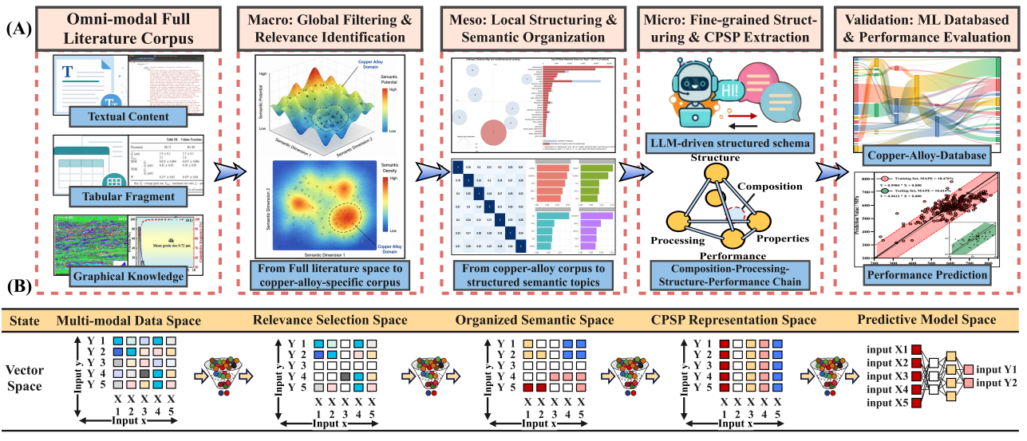
Fig. 1. Overview of the proposed Corpus–Topic–Document framework for literature-driven copper alloy informatics. (A) Schematic illustration of the end-to-end workflow, consisting of multi-modal literature corpus construction, corpus-level semantic filtering and relevance identification, topic-level knowledge organization, document-level fine-grained CPSP reconstruction, and ML-ready knowledge resource construction for downstream performance prediction and alloy design. (B) Hierarchical representa-tion of information transformation within the CTD framework, where literature information is progressively organized from multi-modal data to structured CPSP resources along the horizontal axis, while composition, processing, structure, and property information are continuously aligned across different representation spaces along the vertical axis.

2. Corpus–Topic Semantic Organization: From Literature Filtering to Knowledge Structuring
To address ambiguous semantic boundaries in keyword-retrieved alloy literature, corpus-level semantic filtering was performed using BERTopic on the large-scale alloy literature corpus. The proposed approach constructs follows hierarchical pipeline “Corpus construction → Semantic embedding → Dimensionality reduction → Density-based clustering → Topic reconstruction → Visualization mapping”, enabling the systematic transformation of the unstructured literature into an interpretable semantic space capturing the organization of diverse alloy research themes. Specifically, publication-level representations were construct-ed by integrating titles, abstracts, author keywords, and keywords plus. These texts were then mapped into a high-dimensional semantic embedding space using the pre-trained SentenceTransformer model all-mpnet-base-v2, with normalization applied to enhance semantic consistency. Subsequently, a decoupled clustering–visualization strategy was used, in which dimensionality reduction supported density-based clustering, while a separate two-dimensional UMAP projection (UMAP-1: -7.899~11.883; UMAP-2: -7.382~10.856) was used only for visualization. The two-dimensional projection was interpreted as a visualization of local semantic neighborhoods rather than as direct evidence of global semantic distances. For clustering, HDBSCAN was applied within BERTopic to identify semantically coherent publication clusters based on local density patterns in the embedding space. Topic representations were then refined using BERTopic’s c-TF-IDF, yielding more representative and interpretable keywords for each cluster. For visualization, an additional distance-based filtering step was applied to remove peripheral points far from central clusters, improving the compactness and visual clarity of the topic map.
As shown in Fig. 2A, the BERTopic–UMAP analysis reveals a heterogeneous yet structured corpus-level semantic distribution within 122,982 alloy-related publications. A total of 457 non-noise BERTopic clusters were identified, with the largest cluster accounting for only 2.57% (3,163 publications), while the remaining clusters exhibited a long-tail distribution. These clusters were used as fine-grained semantic neighborhoods for relevance identification rather than as final high-level research topics. Distinct semantic regions form dense local aggregations in the two-dimensional UMAP projection, suggesting locally coherent semantic neighborhoods. Because UMAP primarily preserves local neighborhood structures and may distort global distances, visual proximity in the projection was not used alone as evidence of semantic overlap. A closer look at the copper-related regions in Fig. 2B shows that copper-alloy-relevant studies are not confined to a single cluster but are distributed across multiple thematic domains, including Mechanics (clustering 8), Corrosion (clustering 6), High-Entropy Alloys (clustering 18), Irradiation (clustering 15), and Shape Memory Alloys (clustering 2). The GT validation shows that both keyword-only and full-metadata lexical retrieval still suffer from substantial omission of relevant Cu-alloy studies, particularly when material identity is expressed implicitly through alloy-specific terminology, processing conditions, phase information, or structure-property context. By representing publications in a contextual semantic space, BERTopic–UMAP can recover these lexically under-specified studies while limiting the remaining semantic noise to a small number of adjacent non-Copper-base, interface, coating, and electrolysis-related records. As a result, BERTopic–UMAP achieved an F1-score of 98.8% and 100% conditional recall within the evaluated cohort. Detailed benchmark construction, error analysis, and comparative results are provided in Supplementary Note S5 and Supplementary Tables S5–S6.
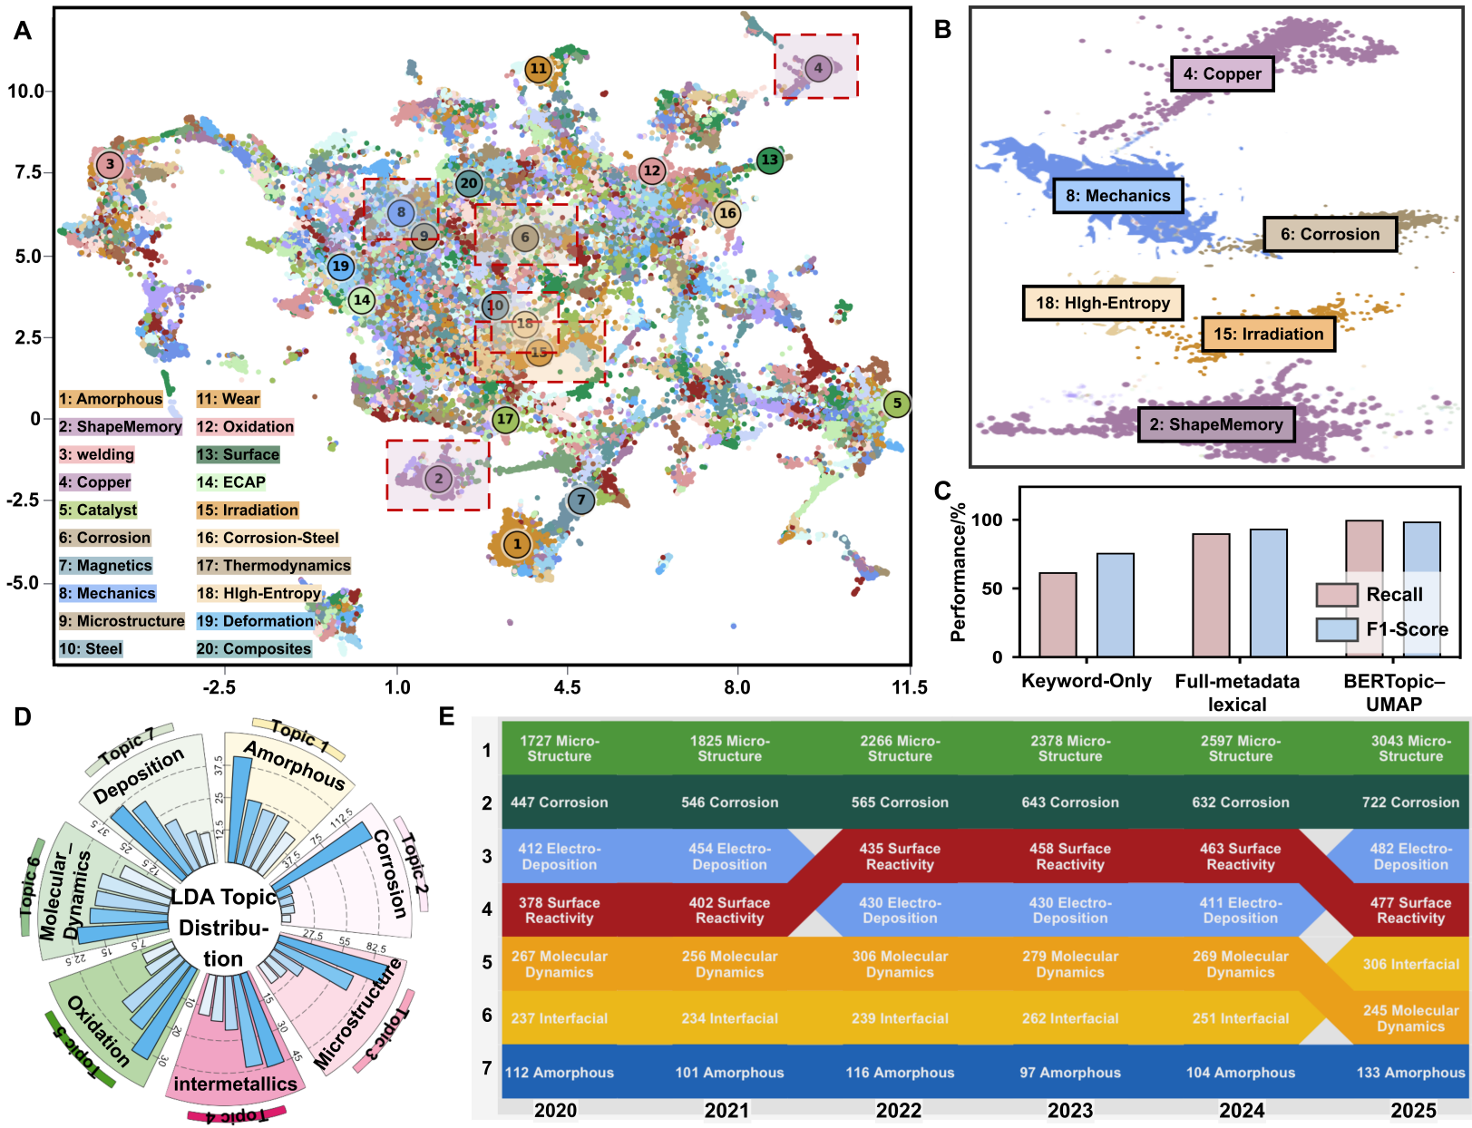
Fig. 2. Corpus–Topic semantic organization of alloy literature using BERTopic-UMAP and LDA. (A) UMAP visualization of the corpus-level alloy semantic space constructed from 122,982 publications, where each point represents a publication and colors indicate BERTopic-derived semantic clusters. (B) Enlarged view of representative corpus-level semantic regions, highlighting the distribution of copper-related studies across multiple domains. (C) Ground-truth comparison of recall and F1-score for keyword-only retrieval, full-metadata lexical retrieval, and BERTopic–UMAP semantic filtering on the 500-publication validation cohort. (D) LDA-based topic distribution, illustrating the hierarchical organization of major research themes and their relative proportions within the corpus. (E) Temporal evolution of topic distributions over 2020–2025, illustrating changes in research focus across major copper-alloy-related themes.
Building upon corpus-level semantic filtering, Fig. 2D-E, Fig. 3A-D, and Table 1 further characterize topic-level knowledge structure, statistical validity, and semantic composition of the copper-alloy-relevant corpus using LDA. Fig. 2E further illustrates the temporal evolution of major research themes from 2020 to 2025. While structure-property-related studies remained consistently dominant, topics such as corrosion, deposition, and interfacial reactions exhibited varying levels of growth and decline, indicating dynamic shifts in research priorities within the copper-alloy field. Detailed trend analyses of publishers, journals, institutions, keywords, and funding agencies are provided in Supplementary Figure 1. As shown in Fig. 3A, the coherence score reaches its maximum when the topic number is seven, indicating that seven topics provide the most semantically consistent representation of the filtered copper-alloy corpus. Nevertheless, topic coherence was used only as the initial statistical criterion for model selection. The final seven-topic organization was further supported by the semantic separability and metallurgical interpretability of the reconstructed topics, avoiding both excessive topic merging and unnecessary semantic fragmentation. Based on this optimized topic configuration, the topic distribution in Fig. 2C shows a structured yet non-uniform pattern, where dominant themes such as structure–property relationships, corrosion, deposition, interfacial reactions, and amorphous/alloy systems occupy the center of the knowledge landscape. This is consistent with the topic weight distribution in Fig. 3B, which shows uneven contributions, with several dominant topics accompanied by smaller but scientifically meaningful topics, forming a clear long-tail structure.
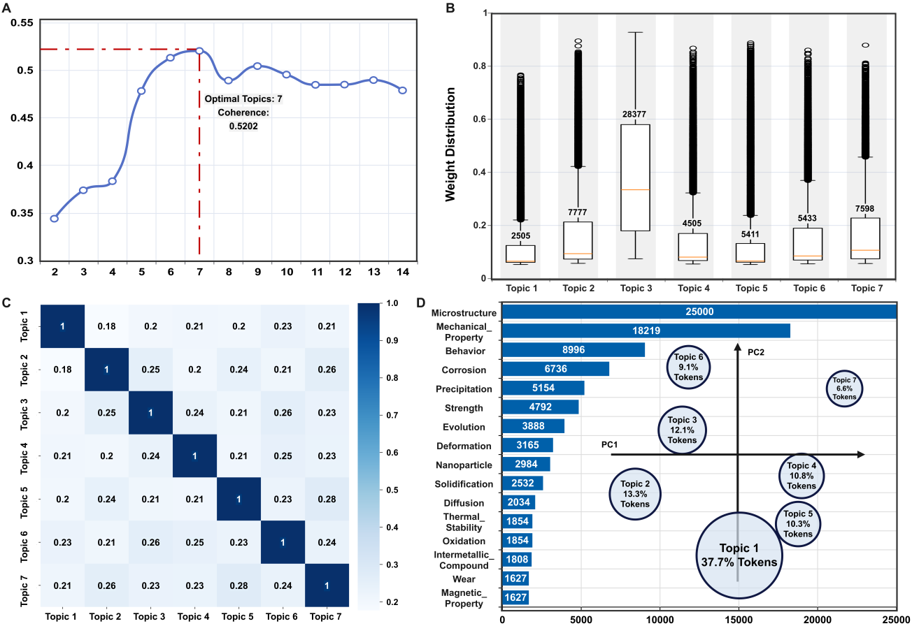
Fig. 3. Topic-level knowledge organization and statistical characteristics of the copper-alloy-relevant literature corpus. (A) Variation of coherence score with the number of topics, indicating an optimal topic number of 7. (B) Topic weight distribution, reflecting the relative contributions of different topics within the corpus. (C) Topic correlation matrix, illustrating the semantic relationships among topics. (D) Keyword frequency distribution and two-dimensional projection of topics in the principal component space, where circle size represents the proportion of each topic in the corpus.
Furthermore, Fig. 2D and Fig. 3D reveal the temporal evolution of research focus and its underlying keyword-level semantic basis. Structure-related studies consistently maintain a high proportion, under-scoring their central role in copper alloy research, while topics such as corrosion, surface reactions, electrodeposition, molecular dynamics, and interfacial phenomena exhibit noticeable temporal variations. This trend is further supported by the keyword distribution in Fig. 3D, where terms such as microstructure, mechanical properties, corrosion, precipitation, and strength define the core semantic regions. Overall, these results suggest that copper alloy research is increasingly organized around coupled structure–property relationships, multi-mechanism strengthen-ing, and multi-scale investigations. The inter-topic similarity heatmap in Fig.3C indicates low-to-moderate correlations, suggesting that the LDA topics are generally distinguish-able while maintaining limited semantic connections. Overall, these results demonstrate that the reconstructed seven-topic organization is not merely a statistically optimal partition of the corpus, but also corresponds to established research directions in copper alloy science. Consequently, the resulting topic structure provides a scientifically interpretable organization of the copper alloy literature.

Table 1. LDA topic probability distribution of the copper alloy literature corpus
Topic | Representative Research Theme | Topic Contents | Probability
Topic 1 | Amorphous alloys and thermal stability | 0.041*"Thermal_stability" + 0.030* "Metallic_glass" + 0.025* "Magnetic_ property" + 0.023* "Crystallization" + 0.023*" Amorphous_ alloy" + 0.022*"Cu" +0.022 *"Bulk_metallic_ glass" + 0.020* "High_ entropy_ alloy" + 0.019* "Glass_forming_ ability" + 0.012* "Plasticity" | 6.67%
Topic 2 | Corrosion behavior and surface protection | 0.074*"Corrosion" + 0.054*"Copper" + 0.026 * "Alloy" + 0.025* "Corrosion_ resistance" + 0.019* "Resistance" + 0.018* "Wear" + 0.016*" Coating" + 0.015* "Behavior" + 0.012*"Copper_alloy" + 0.012* "Steel" | 13.35%
Topic 3 | Microstructure–property relationships and precipitation strengthening | 0.095*"Microstructure" + 0.071* "Mechanical_ properties" + 0.039* "Alloy" + 0.030* "Behavior" + 0.020*"Precipitation" + 0.019*" Strength" + 0.016* "Copper" + 0.015*"Evolution" + 0.013*" Aluminum_ alloy" + 0.012*"Deformation" | 36.61%
Topic 4 | Interfacial reactions and joining technologies | 0.028*"Cu" + 0.026*"Interface" + 0.026* "Intermetallic_compound" + 0.025*"Joint" + 0.022* "Alloy" + 0.021*" Shape_ memory_ alloy" + 0.019* "Solder" + 0.019*"Inter-metallic" + 0.019* "Stainless_steel"+ 0.017* "Interfacial_ reaction" | 10.22%
Topic 5 | Nanostructured functional copper materials | 0.040*"Catalyst" + 0.032*"Nanoparticle" + 0.025* "Oxidation" + 0.019*"Copper" + 0.016* "Electro-catalyst" + 0.015* "Reduction" + 0.012* "Alloy" + 0.012*"Cu" + 0.011* "Performance" + 0.011*" Surface" | 8.9%
Topic 6 | Solidification and computational metallurgy | 0.038*"Alloy" + 0.021*"Solidification" + 0.019* "System" + 0.018* "Diffusion" + 0.017*"Molecular_ dynamics" + 0.017* "Segregation" + 0.015*"Growth" + 0.013* "Simulation" + 0.013*" Cu" + 0.012* "Iron" | 11.11%
Topic 7 | Electro-deposition and thin-film fabrication | 0.039*"Copper" + 0.026*"Alloy" + 0.024* "Electrodeposition" + 0.023*"Cu" + 0.021* "Fabrication" + 0.018*"Film" + 0.016* "Thin_film" + 0.014*"Deposition" + 0.014*" Mechanical_ alloying" | 13.15%

- Document-level: Fine-grained multi-modal CPSP reconstruction
At the document level, fragmented alloy knowledge distributed across text, tables, and literature figures is reconstructed into machine-readable CPSP data chains through a tri-track multi-modal extraction architecture, consisting of textual, tabular, and visual processing pipelines (Fig.4). The collected XML/ HTML full texts were first parsed into hierarchical section–paragraph structures and transformed into machine-readable JSON representations containing section identifiers, titles, and paragraph-level semantic units. Subsequently, rule-based semantic segmentation and structured-prompt-guided LLM extraction were combined to reconstruct fragmented metallurgical descriptions into schema-aligned CPSP records, transforming composition, processing, structure, property, and strengthening-mechanism information into hierarchical “entity–condition–attribute–value” relationships. Unlike conventional entity extraction, the proposed framework reconstructs sequential metallurgical processes into complete CPSP chains rather than isolated processing entities. For example, processing descriptions scattered across different sections of a publication are semantically linked to generate unified processing sequences such as “Solution Treatment → Quenching → Deformation → Aging → Secondary Thermo-Mechanical Processing (TMP) → Secondary Aging”. During reconstruction, intermediate processing conditions (temperature, time, deformation ratio and cooling method) are associated with each processing step and further linked with the corresponding alloy composition, microstructure evolution and property records, enabling traceable CPSP chain reconstruction.
The tabular pipeline reconstructs structured CPSP information from heterogeneous XML/HTML tables by converting publisher-specific table formats into standardized representations preserving relationships among titles, headers, and cell entries. Abnormal output validation is further employed to identify formatting errors, semantic inconsistencies, and hallucinated entries, thereby improving extraction reliability. Rather than preserving heterogeneous XML/HTML tables, the framework reconstructs each numerical entry into a structured condition–value record, where the experimental context is retained through table titles, headers, and associated conditions. These reconstructed records are subsequently integrated into the CPSP repository as standardized machine-readable data points.
The CPSP image structuring pipeline extends the framework to literature figure extraction and categorization. Figure links, captions, and metadata are first extracted from XML/HTML articles, followed by automated image downloading and multi-panel figure splitting. VLMs are then used to classify scientific figures into microstructural images (e.g., SEM, TEM, EBSD, and OM), diffraction patterns (e.g., XRD and SAED), schematic diagrams, statistical plots, and performance curves. Quantitative plots with explicit axes and scales are digitized through axis detection, scale calibration, and curve tracing, with the extracted x–y data linked to axis labels, units, captions, alloy compositions, processing conditions, and publication identifiers. In contrast, microstructural images are linked with their captions, sample identifiers, processing conditions, and associated textual descriptions to reconstruct structural evidence within the CPSP data chain, rather than being directly converted into standardized numerical features. This is because microstructural interpretation, including phase identification, precipitate morphology, grain refinement, and defect structures, is highly context-dependent, while quantitative descriptors such as precipitate and grain sizes are difficult to standardize across heterogeneous imaging and statistical protocols. Therefore, image-derived structural information is retained as traceable CPSP knowledge and cross-modal evidence rather than directly incorporated into the ML feature matrix. Finally, textual, tabular, and graphical outputs are harmonized through a unified CPSP schema using shared identifiers, including DOI, alloy system, composition, processing conditions, structure, properties, and strengthening mechanisms, providing a traceable knowledge base for downstream machine learning, property prediction, and alloy design.

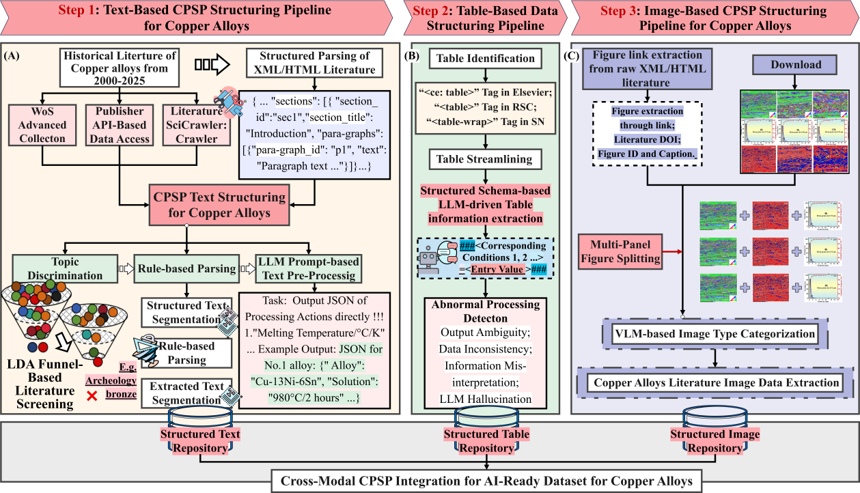
Fig. 4. Document-level multi-modal CPSP reconstruction framework for copper alloys: (A) Text-based CPSP structuring pipeline for transforming unstructured metallur-gical descriptions into machine-readable CPSP records. (B) Table-based structuring pipeline for reconstructing structured CPSP information from heterogeneous literature tables. (C) Image-based structuring pipeline for organizing literature figures, including microstructural images, diffraction patterns, statistical plots, and performance curves. Structured text, table, and image resources are subsequently integrated into a unified CPSP-oriented copper alloy repository.
- Validation of Document-Level Multi-Modal CPSP Reconstruction
As shown in the Fig. 5A–F, representative LLMs exhibited distinct performance across composition, processing, structure, properties, strengthening mechanisms, and heterogeneous table reconstruction. GPT-4-1106-preview achieved the best overall performance across most text- and table-based tasks, with token-level F1-scores generally exceeding 0.90, followed by Claude-3-Haiku and GPT-4o-mini. In contrast, Moonshot-v1-32k and Spark-4.0-Ultra showed greater performance degradation in semantically complex tasks, particularly structure and strengthening-mechanism extraction. Across models, precision generally exceeded recall, indicating that errors were dominated by missed entities in loosely structured descriptions and multi-step processing routes, while BLEU showed greater variability because of its sensitivity to wording and sequence-level structural differences. Different CPSP categories also exhibited distinct extraction characteristics. Distinct extraction characteristics were observed across CPSP categories. Composition achieved the highest overall performance owing to its standardized numerical and elemental expressions, whereas processing showed relatively high precision but lower recall because of nested thermo-mechanical conditions and multi-step dependencies. Structure, properties, and particularly strengthening mechanisms exhibited greater inter-model variability, reflecting their implicit relationships, diverse metallurgical terminology, and higher semantic complexity. For heterogeneous tables, GPT-4-1106-preview and Claude-3-Haiku maintained high token-level accuracy and precision, whereas lightweight models showed greater degradation for irregular layouts. Recall remained particularly sensitive to omitted headers and merged-cell structures, highlighting complex tabular dependencies as a major source of extraction error.
Beyond textual and tabular modalities, VLM-based evaluation was conducted for literature image understanding. As shown in Fig. 5G, most models achieved overall accuracies above 0.90, demonstrating robust coarse-grained image categorization. Fine-grained evaluation (Fig. 5H–L), however, revealed clear modality-dependent differences. Microstructural images (SEM, TEM, EBSD, and OM) showed balanced accuracy, precision, recall, and F1-score owing to their distinctive morphological and contrast features, while statistical plots and performance curves also exhibited stable performance because of their regular graphical elements, such as axes, legends, markers, and curves. In contrast, XRD and SAED exhibited greater fluctuations and lower recall, as diffraction patterns often occupy small regions and coexist with microstructural images within composite figures. Schematic diagrams were similarly more challenging because their interpretation requires semantic reasoning across labels, arrows, process routes, and symbolic elements. These results indicate that VLM-based information extraction remains strongly dependent on the visual and semantic complexity of scientific figures, while the GT workflow integrating automated verifica-tion with human-in-the-loop validation provides a high-accuracy and reliable benchmark for evaluating multi-modal CPSP reconstruction across text, tables, and figures.

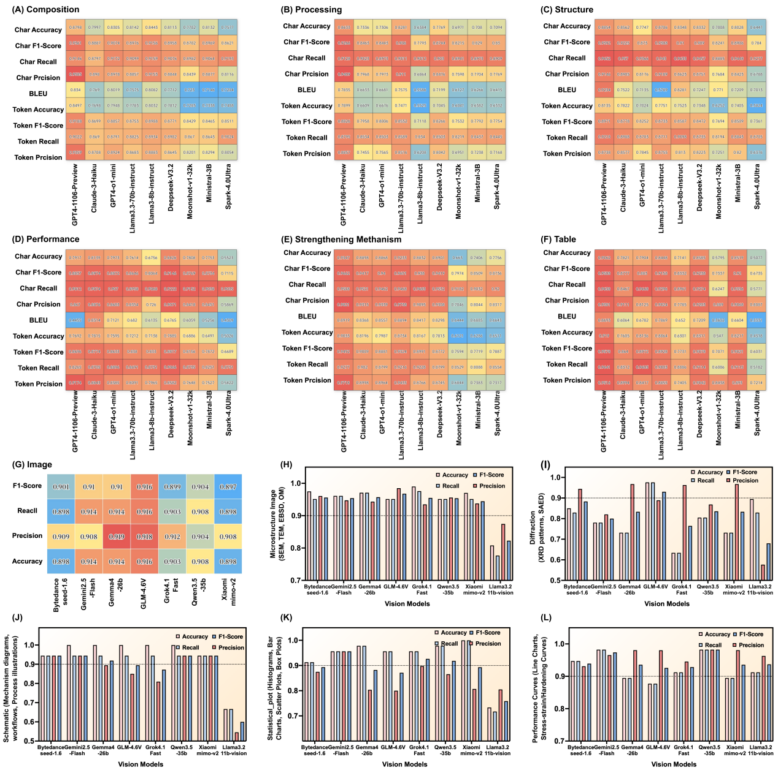
Fig. 5 Benchmark evaluation of LLMs for text- and table-based CPSP extraction and VLMs for scientific figure categorization.(A-F) Heatmap comparison of text- and table-based extraction performance across six CPSP-related categories, including composition, processing, structure, performance, strengthening mechanism, and tabular information. (G) Overall categorization performance of representative VLMs for literature figure understanding. (H-L) Category-level evaluation of VLM-based figure categorization tasks, including microstructural images (SEM, TEM, EBSD, OM), diffraction patterns (XRD plots and SAED patterns), schematic mechanism diagrams, statistical plots (histograms, bar charts, and box plots), and performance curves (line charts and stress-strain/hardening curves).

5. Downstream Validation: Rapid Data-Driven Copper Alloy Design Enabled by ML

5.1 Data-Driven Feature Engineering and Multi-objective Prediction of Copper Alloys
To evaluate the applicability of the reconstructed CPSP resources for data-driven copper alloy design, 3,358 CPSP records were selected from 9,284 ML-ready data chains by retaining samples with comparable thermo-mechanical processing histories following the route of “Solution → Quenching → Deformation → Aging → Secondary TMP → Secondary Aging” across representative Cu–Ni–Si- and Cu–Cr-based alloy systems. Based on these data, multi-objective machine-learning (ML)models were developed for hardness, electrical conductivity and Q3-Euclidean prediction, while the CPSP-oriented feature engineering workflow was employed to identify key descriptors governing composition–processing–structure–performance relationships. To ensure cross-record consistency and sufficient data coverage, only descriptors that were consistently defined and broadly available across the reconstructed CPSP records were included as ML inputs. Although structural information extracted from text, tables, and microstructural figures was preserved within the CPSP repository for mechanistic interpretation and cross-modal validation, image-derived microstructural descriptors were not used as universal numerical features because of their heterogeneous reporting and limited availability across the literature. The dataset was randomly divided into training and testing subsets using an 8:2 ratio, with the testing set reserved for independent evaluation. Within the feature engineering stage, a three-step CPSP-oriented feature screening strategy consisting of correlation filtering, permutation-importance refinement, and combinational optimization was employed to identify key factors governing multi-objective properties in these copper alloy systems [4,40]. As shown in Fig. 6A–6C, Pearson correlation analysis was first performed on the training set to identify features correlated with the target properties from composition-, thermodynamic-, processing-, and physicochemical-related feature spaces, while excluding weakly relevant and redundant variables. Subsequently, recursive feature refinement based on permutation importance and statistical contribution analysis was applied within training set to iteratively eliminate low-contribution features and construct more compact and representative feature subsets (Fig. 6D–6F). Finally, exhaustive combinational searches were performed over the remaining feature subsets to determine the optimal feature combinations by minimizing cross-validation prediction errors within the training set (Fig. 6G–6I).
Based on the optimized CPSP feature subsets, predictive models were developed for representative Cu–Ni–Si–Al–Cr–Mg, Cu–Cr, Cu–Cr–Ni–Si, and Cu–Ni–Si alloy systems. As shown in Fig. 7D–7R, the proposed CTD framework achieved consistently good predictive performance for hardness, electrical conductivity, and the Q3-Euclidean index across different alloy systems. Hardness prediction generally exhibited the highest accuracy, whereas Q3-Euclidean showed greater variability owing to the increased complexity of simultaneously optimizing mechanical strength and electrical conductivity.
To further demonstrate how the proposed framework translates literature knowledge into practical alloy design, an integrated knowledge-to-design workflow is summarized in Fig. 8. Although the optimized CPSP feature subsets and prediction models provide reliable property prediction, the primary objective of the CTD framework extends beyond predictive modeling to the transformation of literature-derived CPSP knowledge into interpretable and experimentally actionable metallurgical design strategies. Using the Cu–Ni–Si alloy system as a representative example, Fig. 8A illustrates how the reconstructed CPSP knowledge is translated into three literature-derived metallurgical design principles: optimization of the Ni/Si ratio, thermo-mechanical processing control, and moderate Cr microalloying. These principles are systematically extracted from literature-organized CPSP relationships and subsequently guide alloy compositional and processing optimization, providing an interpretable knowledge-mining strategy to data-driven material develpment. For multi-objective alloy design, candidate alloys were first identified from the Pareto-optimal region defined by hardness and electrical conductivity (Fig. 8B). Furthermore, progressive comparisons among raw composition–processing features, conventional physicochemical descriptors, and CTD-guided

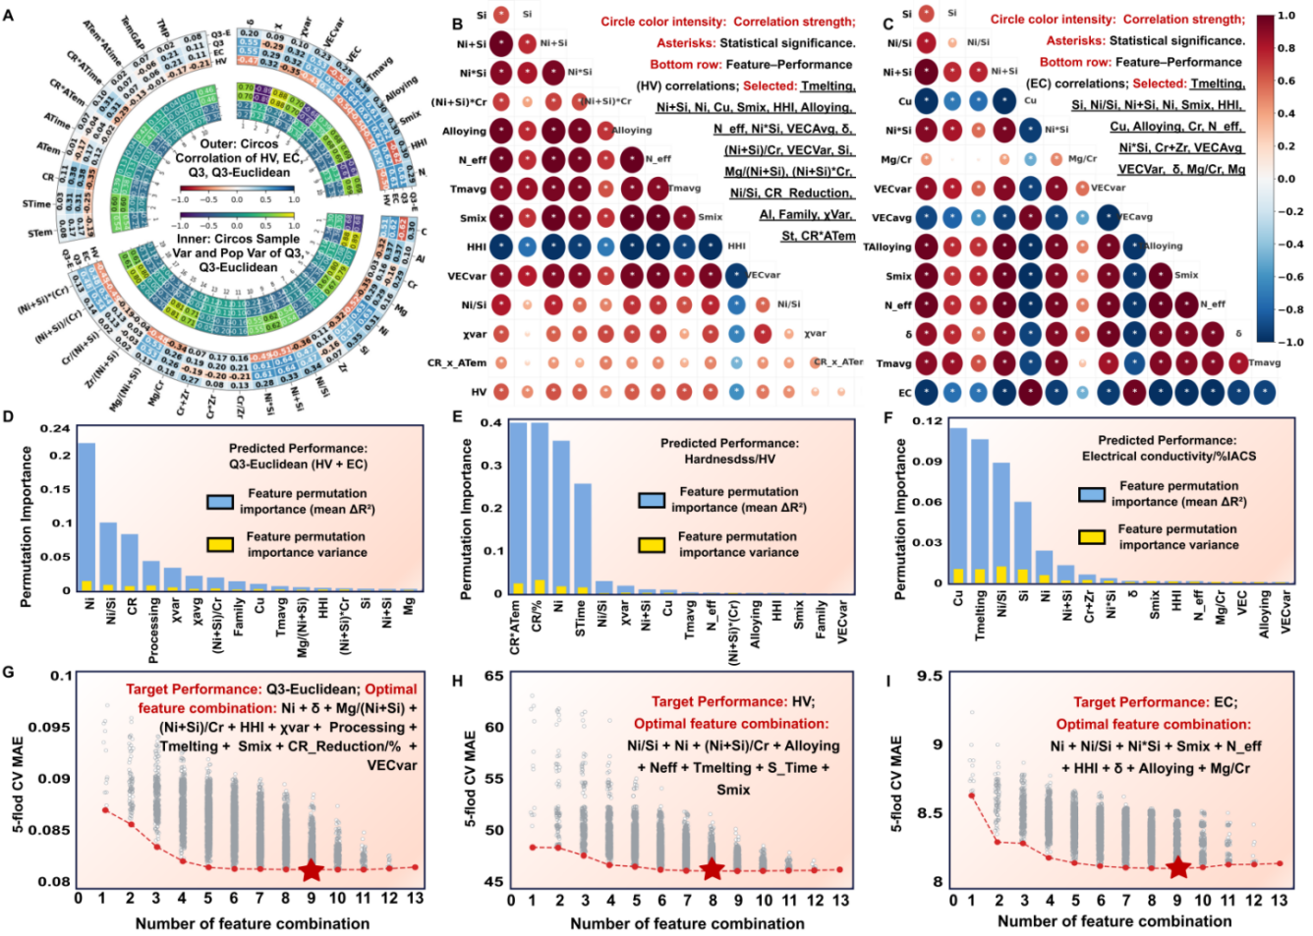
Fig.6. Three-step CPSP-oriented feature selection strategy for downstream machine learning. (A-C) Pearson correlation filtering for Q3-Euclidean, hardness, and electrical conductivity, performed on the training set to remove weakly correlated or redundant features. (D-F) Permutation-importance-based recursive feature refinement for identifying key descriptors associated with each target property. (G-I) Exhaustive search of the remaining feature combinations, showing the variation of mean absolute error (MAE) with feature subset size and the resulting optimal feature subsets.

CPSP features (Fig. 8C–E) demonstrating that literature-derived CPSP knowledge provides additional predic-tive information beyond conventional feature engineering, thereby establishing an interpretable pathway from literature knowledge to knowledge-guided alloy design. The scientific basis of these design principles is further supported by the combined SHAP interpretation (Fig. 7A–C) and Pearson correlation analysis (Fig. 8F), both of which reveal pronounced target-dependent CPSP relationships. Hardness is mainly associated with deformation-related parameters, the Ni/Si ratio, and precipitation-related thermodynamic descriptors, whereas electrical conductivity is primarily governed by aging conditions, elemental concentrations, and electron-scattering-related descriptors. As an integrated metric, the Q3-Euclidean index depends on a broader combination of compositional, processing, and thermodynamic descriptors, demonstrating that balanced strength–conductivity performance requires coordinated regulation of multiple CPSP pathways rather than optimization of a single controlling variable. Fig. 8G shows that prediction-error reduction can be broadly attributed to four components, physicochemical features, CTD-derived knowledge, model optimization, and residual error with target-dependent proportions. CTD-derived design-rule provide the largest contribution across all three targets, followed by conventional physico-chemical features, whereas model optimization and residual error account for comparatively smaller fractions. This indicates that the predictive gains arise primarily from knowledge- and physics-informed feature representation rather than increased model complexity alone.
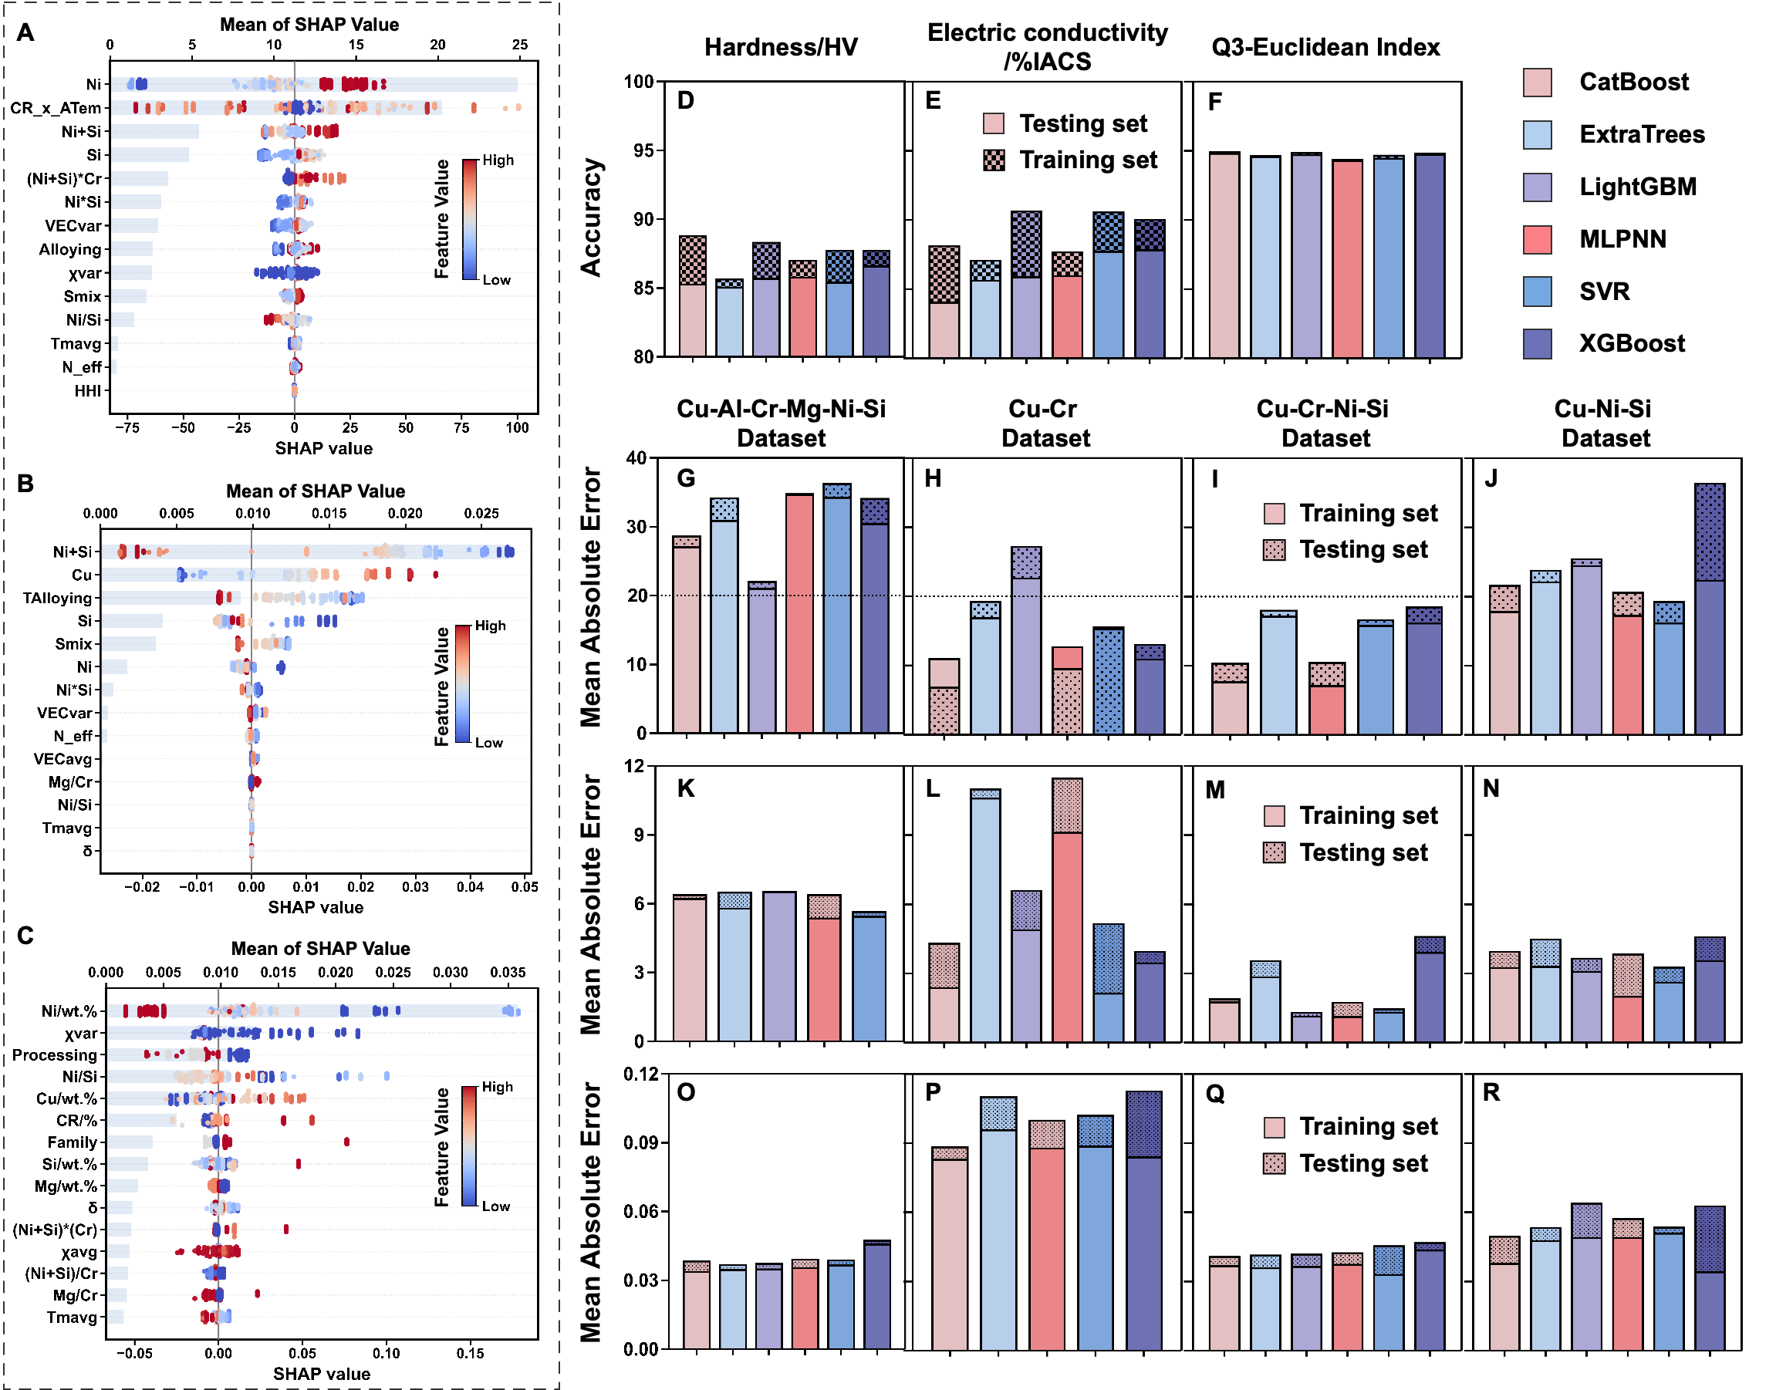
Fig. 7. SHAP feature interpretation and ML prediction performance for representative copper alloy systems. (A–C) SHAP feature importance analysis for hardness, electrical conductivity, and Q3-Euclidean. (D–F) Prediction accuracy of different machine-learning models across Cu–Ni–Si–Al–Cr–Mg, Cu–Cr, Cu–Cr–Ni–Si, and Cu–Ni–Si datasets using an 80:20 train–test split. (G–R) Mean absolute error (MAE) comparison for hardness, electrical conductivity, and Q3-Euclidean prediction across different alloy systems and models.

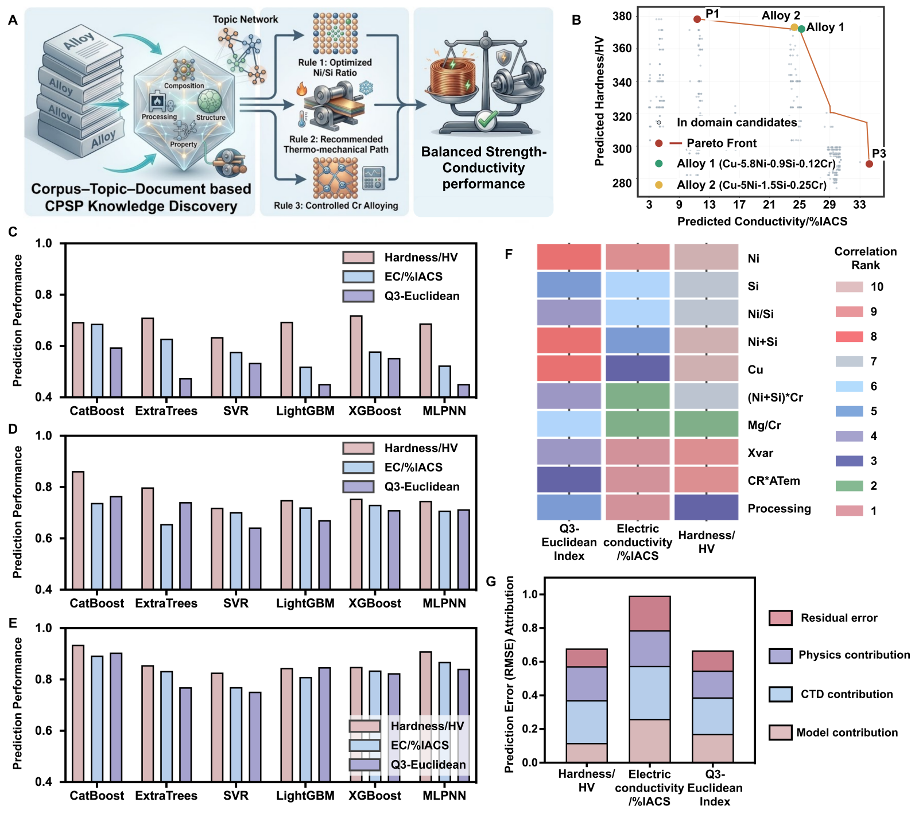
Fig. 8. CTD-derived CPSP knowledge enables interpretable multi-objective copper alloy design. (A) Translation of CTD-derived CPSP knowledge into metallurgical design principles, including optimization of the Ni/Si ratio, thermo-mechanical processing, and moderate Cr microalloying. (B) Prediction Pareto front for the hardness and electrical conductivity with the experimentally validated Cu–Ni–Si–Cr alloy candidates. (C–E) Comparison of prediction performance using raw composition/processing features, conventional physicochemical feature emgineering, and CTD-guided feature engineering. (F) Pearson correlation heatmap showing the distinctions between representative features with hardness, electrical conductivity, and the Q3-Euclidean index. (G) Schematic of prediction uncertainty attribution, including literature uncertainty, model approximation, CTD knowledge representation, and remaining physical-information limitations.

5.2 CPSP-Guided Experimental Validation and Microstructural Mechanism Analysis
Representative Cu–Ni–Si–Cr alloys optimized through the CPSP-guided machine-learning framework were experimentally fabricated and systematically characterized. As shown in Fig. 8A–B, both optimized Cu–Ni–Si–Cr alloys exhibited typical precipitation-hardening behavior during aging treatment. At 450 °C, hardness increased gradually without obvious over-aging-induced softening, indicating relatively sluggish precipitation kinetics. When the aging temperature increased to 460 °C, a typical peak-aging response was observed, with hardness rapidly increasing to a maximum at approximately 20–30 min before gradually decreasing. Further increasing the temperature to 475 °C significantly accelerated both hardening and over-aging due to enhanced precipitate nucleation, growth, and coarsening kinetics. Meanwhile, electrical conductivity continuously increased with aging time under all aging conditions, mainly owing to the depleti-
on of supersaturated solute atoms from the Cu matrix during precipitation.
As shown in Table 2, under the optimized peak-aged condition of 460 °C for approximately 20–30 min, the Cu–5.8Ni–0.95Si–0.12Cr alloy achieved 369 HV, 23.81 %IACS, 1097 MPa tensile strength, and ~5% elongation. The Cu–5Ni–1.5Si–0.25Cr alloy exhibited further improved properties, reaching 375 HV, 25.27 %IACS, 1133 MPa tensile strength, and ~8% elongation.The corresponding prediction results showed good agreement with the experimental measurements, with hardness prediction errors remaining within ~6% and electrical conductivity prediction errors of 4.75% and 13.37% , for the Cu–5.8Ni–0.95Si–0.12Cr and Cu–5Ni–1.5Si–0.25Cr alloys, respectively. The larger deviation in electrical conductivity can be attributed to its stronger sensitivity to microstructure-dependent electron-scattering sources, such as residual solute atoms, precipitate distribution, dislocation density, and interfacial structures, which are difficult to fully describe using current CPSP framework [2,31–32]. The engineering stress–strain curves in Fig. 8C demonstrate the favorable strength–conductivity–ductility balance of the optimized alloys. Compared with Cu–5.8Ni–0.95Si–0.12Cr, Cu–5Ni–1.5Si–0.25Cr exhibited simultaneously improved strength and ductility, which can be attributed to its optimized precipitation state and Ni/Si ratio.
Table 2 Experimental validation of experimental and predicted properties of peak-aged Cu alloys
Alloy | Processing-Route | Experimental Value  (Peak-Aged State) |  | Prediction (Error %)
 |  | Hardness  /HV | Electricial Conductivity  /%IACS | Hardness  /HV | Electricial Conductivity  /%IACS
Cu-5.8Ni-0.9Si-0.12Cr | Homo 960℃/4h → HR 80% → ST 980℃/4h → CR 50% → Aging | 369 | 23.81 | 346  (6.23%) | 24.94  (4.75%)
Cu-5Ni-1.5Si-0.25Cr | Homo 960℃/4h → HR 80% → ST 980℃/4h → CR 50% → Aging | 375 | 25.27 | 352  (6.13%) | 28.65  (13.37%)
Notes: Homo =homogenization treatment; HR = hot rolling; ST = solution treatment; CR = cold rolling; Aging = aging treatment.

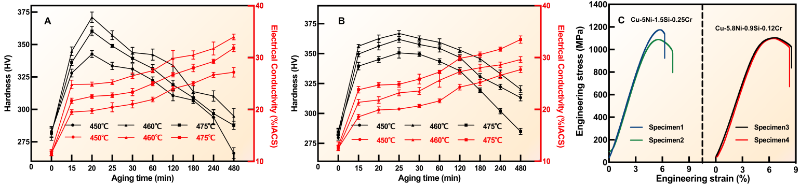
Fig. 8. Experimental validation of CPSP-guided Cu–Ni–Si–Cr alloy design. (A–B) Aging hardness and electrical conductivity evolution curves of Cu–5.8Ni–0.95Si–0.12Cr and Cu–5Ni–1.5Si–0.25Cr alloys under different aging temperatures. (C) Engineering stress–strain curves of representative peak-aged Cu–Ni–Si–Cr alloys. The results demonstrate the strength–conductivity–ductility balance achieved through CPSP-guided alloy optimization.

Fig. 9 presents the TEM and STEM characterization results of the peak-aged Cu–Ni–Si–Cr alloy after cold deformation. As shown in the Fig. 9a, a high density of dislocation tangles and dislocation walls was retained in the Cu matrix after aging, suggesting that deformation-induced substructures were only partially recovered during peak-aging treatment. These retained substructures may contribute to dislocation/ substructure strengthening and are likely associated with preferential precipitation of Ni-Si-rich phases [8, 31]. These observations are consistent with a deformation-assisted precipitation process, resulting in a heterogeneous microstructure composed of dislocation walls, nanoscale precipitates, and locally recovered or recrystallized regions. The HRTEM image in Fig. 9b reveals fine precipitates embedded in Cu matrix, while the corresponding FFT pattern in Fig. 9c supports their crystallographic identification. Further crystallographic analysis of a representative precipitate, shown in Fig. 9e and f, indicates the following orientation relationship:
$$\text{[110] }\text{Cu}\text{ // [11}\text{2}\text{] }{\text{Ni}}_{\text{2}}\text{Si}$$
This relationship suggests a specific lattice correspondence between the Cu matrix and the Ni₂Si precipitate.
Such an orientation relationship may indicate a coherent or semi-coherent interfacial configuration, which is favorable for maintaining a fine precipitate dispersion during aging. The nanoscale precipitates are therefore expected to contribute to precipitation strengthening through interactions with gliding dislocations [7]. The bright-field TEM image in Fig. 9d further demonstrates the coexistence of retained dislocation walls, nano-scale precipitates, and locally recovered/recrystallized regions. The persistence of dense deformation sub-structures indicates incomplete recrystallization, whereas the presence of fine precipitates suggests that precipitation may retard dislocation recovery and sub-boundary migration, thereby suppressing excessive recovery and grain/subgrain coarsening. The HAADF-STEM image and STEM-EDS elemental maps in Fig. 9g and h show a relatively uniform distribution of Ni and Si, without obvious coarse segregation or continuous grain-boundary precipitation. This relatively homogeneous precipitation state is beneficial for both mechanical strengthening and electrical transport, as precipitation removes Ni and Si solutes from the Cu matrix and reduces solute-related electron scattering. The precipitate-size distribution in Fig. 9i shows that the Ni₂Si precipitates have an average size of 4.39 ± 1.25 nm (mean ± SD, n = 62), with measured sizes ranging from 2.52 to 7.29 nm and most particles concentrated within 3–5 nm. This relatively narrow size distribution indicates limited precipitate coarsening, consistent with the fine and dense precipitation characteristic of the peak-aged state. Therefore, the enhanced strength of the alloy originates from combined effects of retained deformation substructures and finely dispersed Ni₂Si precipitates, while the improved conductivity is associated with solute depletion from the Cu matrix during precipitation [2-3]. The micro-structural evidence in the Fig.9 therefore provides mechanistic support for the strength–conductivity synergy achieved through CPSP-guided alloy design.
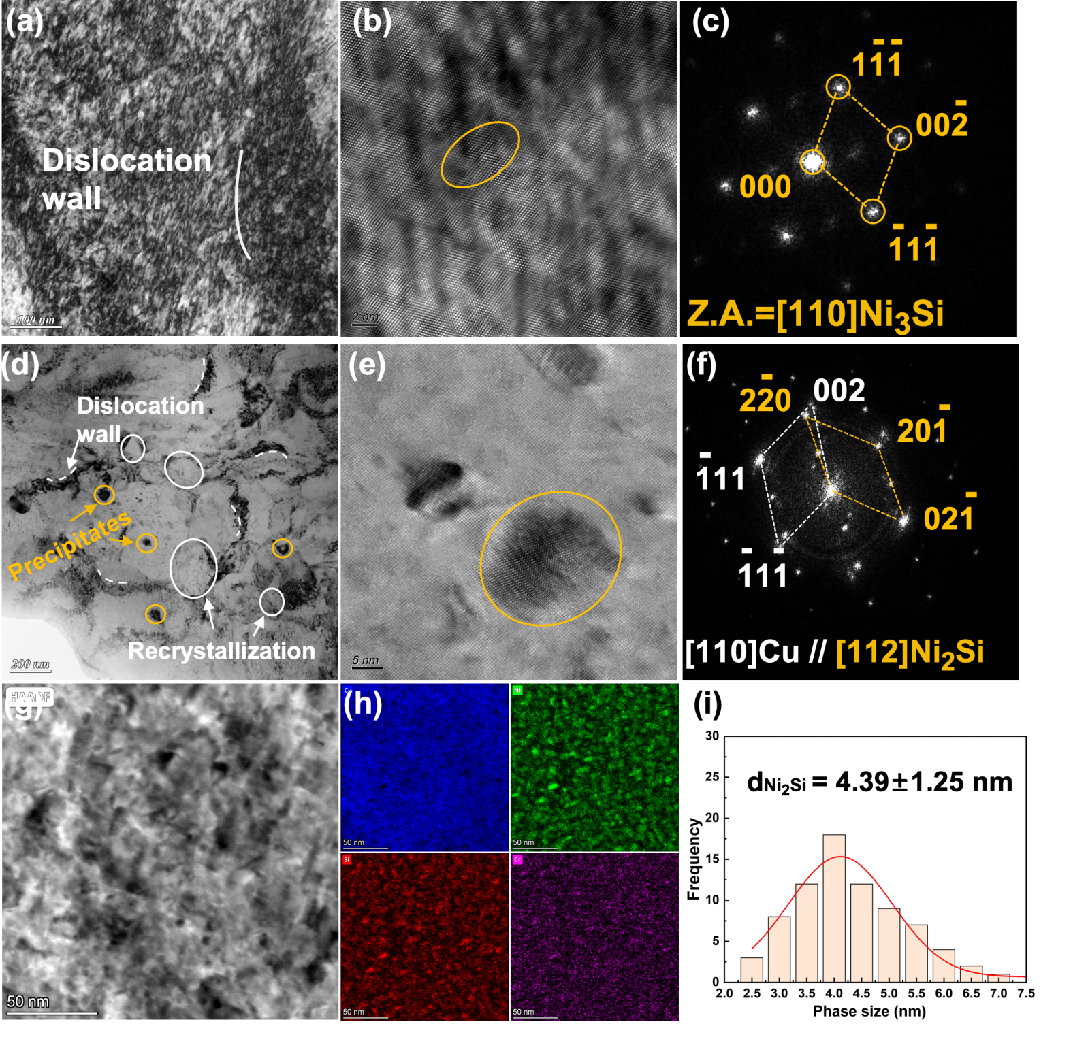
Fig. 9. TEM/STEM characterization and precipitation analysis of the peak-aged Cu–Ni–Si–Cr alloy after cold deformation. (a) Low-magnification TEM image showing retained high-density dislocation sub-structures and dislocation walls in the deformed Cu matrix. (b) HRTEM image of nanoscale precipitates embedded in the Cu matrix. (c) Corresponding FFT pattern of the precipitate marked in (b), indexed as Ni₃Si viewed along the [110] zone axis.(d) Bright-field TEM image showing the coexistence of dislocation walls, nanoscale precipitates, and locally recrystallized regions. (e) HRTEM image of a representative nanoscale precipitate in the matrix. (f) Corresponding SAED/FFT pattern revealing the crystallographic relationship between the Cu matrix and Ni₂Si precipitate, with [110]Cu//[112]Ni₂Si. (g) HAADF-STEM image of the aged microstructure. (h) STEM-EDS elemental maps of Cu, Ni, Si, and Cr, showing the elemental distribu-tion in the observed region. (i) Statistical analysis of the TEM images yielded an average precipitate size of 4.39 ± 1.25 nm (mean ± SD, n = 62), with sizes ranging from 2.52 to 7.29 nm (Fig. 9i).
Discussions
Conventional data-driven materials research is predominantly dataset-centered, relying on manual literature collection and static dataset construction prior to machine-learning modeling. Although such workflows have been widely adopted for property prediction and alloy optimization, they generally treat scientific literature primarily as a data source and provide limited support for organizing the broader knowledge landscape or understanding knowledge evolution within a research field [46–48]. This limitation becomes particularly evident for CPSP knowledge, which is inherently difficult to organize because the corresponding scientific evidence is fragmented across textual descriptions, heterogeneous tables, and scientific figures [49]. Moreover, a single publication often reports multiple alloy compositions, processing conditions, microstructural states, and property measurements simultaneously, resulting in complex many-to-many relationships among CPSP components. Consequently, directly transforming literature into structured and reusable CPSP resources remains challenging [50]. To address this challenge, the proposed Corpus–Topic–Document (CTD) framework progressively organizes scientific literature into machine-readable CPSP resources. It combines large-scale semantic discovery and thematic knowledge organization with document-level reconstruction of fragmented textual, tabular, and graphical evidence, thereby linking research-landscape analysis with data-driven alloy discovery.
The resulting CPSP resources can be reorganized according to alloy system, target property, or metallurgical task, enabling task-oriented dataset generation without repeatedly constructing independent alloy-specific databases. Importantly, experimental context is retained together with each reconstructed record rather than removed during data standardization. Parameters that may influence reported results, such as melting equipment, atmosphere, and casting conditions; corrosion medium, temperature, and electrochemical settings; or fatigue loading mode, stress ratio, frequency, and testing standard are extracted whenever available and stored with the corresponding CPSP information. These experimental conditions are retained together with each CPSP record, allowing data obtained under different experimental conditions to be identified and filtered separately, which reducing the influence of noise and uncertainties of experiment on subsequent modeling. The proposed framework is not intended to replace commercial or institutional databases, which generally provide highly curated and standardized materials data. Instead, it complements these resources by providing a scalable pathway for continuously converting newly published scientific literature into reusable CPSP knowledge. While curated databases mainly archive validated experimental records, the CTD framework continuously captures newly emerging knowledge, preserves its scientific context, and organizes it into AI-ready knowledge resources before manual curation becomes available. Consequently, CTD serves as an upstream knowledge acquisition framework, whereas commercial databases function as downstream knowledge repositories.
Despite these advances, several limitations remain. The current framework should be interpreted within the scope of repository-level integration. Textual, tabular, and figure-derived information are primarily linked through shared metadata, such as DOI, alloy system, composition, processing route, and performance descriptors, rather than through fully automated entity-level alignment. Consequently, the reconstructed CPSP chains represent coordinated organization of heterogeneous knowledge sources rather than complete cross-modal semantic fusion [51]. A further limitation concerns the incorporation of literature-derived micro-structural information into downstream ML models ]. Although the present framework reconstructs structural evidence by linking microstructural images with their captions and associated textual descriptions, these image-derived observations are not yet sufficiently standardized to serve as universal numerical descriptors across the literature . Their interpretation depends on author-specific analyses, while quantitative measurements are often obtained using different imaging conditions, sampling strategies, and statistical definitions. Consequently, the current framework uses graphical information primarily to preserve structural knowledge, support cross-modal validation, and maintain CPSP traceability rather than as direct ML inputs. Future work will focus on standardized quantitative image analysis and descriptor normalization to establish structure-aware CPSP prediction models.
Conclusions
In this work, a Corpus–Topic–Document (CTD) framework was developed to transform fragmented scientific literature into machine-readable CPSP knowledge resources for copper alloy informatics. Through corpus-level semantic filtering, topic-level knowledge organization, and document-level CPSP reconstruc-tion, the framework establishes a hierarchical pathway for organizing and utilizing literature knowledge from coarse-grained corpus understanding, through intermediate-grained topic organization, to fine-grained CPSP reconstruction.The framework demonstrated the capability to reconstruct high-quality CPSP resources from large-scale literature and support reliable multi-modal knowledge extraction across textual, tabular, and graphical information sources.The reconstructed CPSP resources were further utilized for machine-learning-guided alloy design and experimental validation, demonstrating their practical value for data-driven copper alloy development. Microstructural characterization further confirmed that the optimized alloy performance originated from coupled deformation–precipitation interactions. More importantly, this work shifts alloy informatics from static dataset construction toward literature-centric knowledge infrastructure development, enabling dynamic CPSP resource organization, task-oriented dataset generation, and reusable knowledge support for alloy discovery. Ultimately, the proposed Corpus–Topic–Document framework provides a scal-able pathway for transforming scientific literature into actionable knowledge resources, bridging scientific literature and alloy discovery through reusable CPSP knowledge infrastructures.

Data availability
The data and code used in this study can be found on the GitHub via: https://github.com/zhaozixuan6678/ Copper-CPSP-infrastructure
Acknowledgements
The authors acknowledge the financial supports by the Advanced Materials-National Science and Technology Major Project (Grant No. 2025ZD0612100), the National Natural Science Foundation of China (Grant No. 52371038), the Science and Technology Innovation Program of Hunan Province (2023RC1019), and the High-Performance Computing Center of Central South University.
Author Contributions
Zixuan Zhao: Conceptualization, Data curation, Coding, Visualization, Modeling, Writing-original draft. Zhikang Xie: Data curation, Experimental Validation. Fei Tan: Experimental Validation, Data analysis, Peiyun Chen, Xiang Liu, Wenqin Xu, Haoran Ouyang: Experimental Validation. Jing He, Yanpeng Ye, Wei Chen: Modeling. Byungju Lee, Tong Xie, Guofu Xu: Writing-review. Yanbin Jiang, Zhou Li: Resources, Project administration, Funding acquisition, Supervision.

- References：
- Wilkinson MD, Dumontier M, Aalbersberg IJ, Appleton G, Axton M, Baak A, et al., 2016. The FAIR Guiding Principles for scientific data management and stewardship. Scientific Data. 3, 160018. https://doi.org/10.1038/ sdata.2016.18.
- Yang H, Ma Z, Lei C, Meng L, Fang Y, Liu J, et al., 2020. High strength and high conductivity Cu alloys: A review. Science China Technological Sciences. 63, 2505-17. https://doi.org/10.1007/s11431-020-1633-8.
- Gorsse S, Ouvrard B, Gouné M, Poulon-Quintin A, 2015. Microstructural design of new high conductivity-high strength Cu-based alloy. Journal of Alloys and Compounds. 633, 42-7. https://doi.org/https://doi.org/10.1016/j. jallcom.2015.01.234.
- Wu C, Liao M, Zhou X, Chen J, Qian X, Wang Y, et al., 2026. Exploring the Pareto front of strength-conductivity trade-off: interpretable machine learning for property prediction and composition design in high-strength high-conductivity Cu alloys. Journal of Materials Informatics. 6, 6.
- Zhang H, Fu H, He X, Wang C, Jiang L, Chen L-Q, et al., 2020. Dramatically Enhanced Combination of Ultimate Tensile Strength and Electric Conductivity of Alloys via Machine Learning Screening. Acta Materialia. 200, 803-10. https://doi.org/https://doi.org/10.1016/ j.actamat.2020.09.068.
- Wang C, Fu H, Jiang L, Xue D, Xie J, 2019. A property-oriented design strategy for high performance copper alloys via machine learning. npj Computational Materials. 5, 87. https://doi.org/10.1038/s41524-019-0227-7.
- Qin Z, Zhao H, Zhang S, Fan Y, Dong X, Lan Z, et al., 2024. Design of high performance Cu-Ni-Si alloys via a multiobjective strategy based on machine learning. Materials Today Communications. 39, 108833. https://doi.org/ https://doi.org/10.1016/j.mtcomm.2024.108833.
- Jiang L, Fu H, Wang C, Li W, Xie J, 2019. Enhanced Mechanical and Electrical Properties of a Cu-Ni-Si Alloy by Thermo-mechanical Processing. Metallurgical and Materials Transactions A. 51, 331-41. https://doi.org/10.1007/ s11661-019-05507-3.
- Yi J, Jia Y, Zhao Y, Xiao Z, He K, Wang Q, et al., 2019. Precipitation behavior of Cu-3.0Ni-0.72Si alloy. Acta Materialia. 166, 261-70. https://doi.org/https://doi.org/10.1016/ j.actamat.2018.12.047.
- Choi J, Lee B, 2024. Accelerating materials language processing with large language models. Communications Materials. 5, 13. https://doi.org/10.1038/s43246-024-00449-9.
- Xie T, Wan Y, Huang W, Zhou Y, Liu Y, Linghu Q, et al., 2023. Large Language Models as Master Key: Unlocking the Secrets of Materials Science with GPT. ArXiv. abs/2304.02213,
- Gupta T, Zaki M, Krishnan NMA, Mausam, 2022. MatSciBERT: A materials domain language model for text mining and information extraction. npj Computational Materials. 8, 102. https://doi.org/10.1038/s41524-022-00784-w.
- Zhao Z, Tan F, Xie T, Chen W, Yu J, Ye Y, et al., 2026. Automated distillation of composition–processing–structure–performance linkages from fragmented and multi-modal materials literature. Materials & Design. 267, 116250. https://doi.org/https://doi.org/10.1016/j.matdes.2026.116250.
- Choi J, Lee B, 2024. Quantitative Topic Analysis of Materials Science Literature Using Natural Language Processing. ACS Appl Mater Interfaces.16,1957-68. https://doi.org/10. 1021/acsami.3c12301.
- Grootendorst MR, 2022. BERTopic: Neural topic modeling with a class-based TF-IDF procedure. ArXiv. abs/2203.05794,
- McInnes L, Healy J, 2018. UMAP: Uniform Manifold Approximation and Projection for Dimension Reduction. ArXiv. abs/1802.03426,
- Tang H, Chen Z, Yao X, Xu Z, 2025. Mechanical performance dataset for alloy with applications at low temperatures. Scientific Data. 12, 1235. https://doi.org/10.1038/s41597-025-05512-9.
- Xu Z, Zhang Z, 2024. The need for standardizing fatigue data reporting. Nature Materials. 23, 866-8. https://doi.org/ 10.1038/s41563-024-01929-6.
- Zhao Y, Zhou H, Zhang Z, Bo Z, Sun B, Jiang M, et al., 2025. Discovering high-strength alloys via physics-transfer learning. Matter. 8, https://doi.org/10.1016/j.matt.2025.102377.
- Yun P, Fu H, Zhang H, Jiang L, Xiao X, Zhu S, et al., 2025. Mechanical and Electrical Properties dataset of Cu-Cr-X alloys generated with automated figure data extraction. Scientific Data. 12, 2023. https://doi.org/10.1038/ s41597-025-06295-9.
- Gorsse S, Gouné M, Lin W-C, Girard L, 2023. Dataset of mechanical properties and electrical conductivity of copper-based alloys. Scientific Data. 10, 504. https://doi.org/10. 1038/s41597-023-02411-9.
- Ding X, Li Y, Chen S, 2024. Maximum margin and global criterion based-recursive feature selection. Neural Networks. 169, 597-606. https://doi.org/https://doi.org/10.1016/j. neunet.2023.10.037.
- Zhang S, Wang WY, Wang X, Li G, Ren Y, Gao X, et al., 2024. Large language models enabled intelligent microstructure optimization and defects classification of welded titanium alloys. Journal of Materials Informatics. 4, 34.
- Miret S, Krishnan NMA, 2025. Enabling large language models for real-world materials discovery. Nature Machine Intelligence. 7, 991-8. https://doi.org/10.1038/s42256-025-01058-y.
- Liu N, Jafarzadeh S, Lattimer BY, Ni S, Lua J, Yu Y, 2025. Harnessing large language models for data-scarce learning of polymer properties. Nature Computational Science. 5, 245-54. https://doi.org/10.1038/ s43588-025-00768-y.
- Blei DM, Ng AY, Jordan MI, 2003. Latent dirichlet allocation. J Mach Learn Res. 3, 993-1022.
- Polak MP, Morgan D, 2024. Extracting accurate materials data from research papers with conversational language models and prompt engineering. Nature Communications. 15, 1569. https://doi.org/10.1038/s41467-024-45914-8.
- Boiko DA, MacKnight R, Kline B, Gomes G, 2023. Autonomous chemical research with large language models. Nature. 624, 570-8. https://doi.org/10.1038/s41586-023-06792-0.
- Wang S, Wan Y, Song N, Liu Y, Xie T, Hoex B, 2024. Automatically Generated Datasets: Present and Potential Self-Cleaning Coating Materials. Scientific Data.11,146. https: //doi.org/10.1038/s41597-024-02983-0.
- Yi GH, Choi J, Song H, Miano O, Choi J, Bang K, et al., 2025. MaTableGPT: GPT-Based Table Data Extractor from Materials Science Literature (Adv. Sci. 16/2025). Advanced Science. 12, 2570114. https://doi.org/https://doi.org/ 10.1002/advs. 202570114.
- Fu H, Zhang Y, Zhang M, Yun X, 2023. Microstructure evolution, precipitation behavior, and mechanical properties of continuously extruded Cu-Ni-Si alloys at different aging treatments. Journal of Materials Processing Technology. 317,117986. https://doi.org/https://doi. org/10.1016/j.jmatprotec.2023.117986.
- Jiang Yb, Zhang Tt, Lei Y, Liu Xh, Cao Y, Xie Jx, et al., 2020. Microstructure evolution and mechanical properties of Cu-0.36Be-0.46Co alloy fabricated by heating-cooling combin-ed mold horizontal continuous casting during cold rolling. Transactions of Nonferrous Metals Society of China. 30, 958-71. https://doi.org/https://doi.org/ 10.1016/S1003-6326(20)65268-2.
- Lu X, Luo S, Li J, Chen M, Yao T, Xu Z, et al., 2025. FIND: a forward-inverse navigation and discovery platform for hydrogen storage alloys powered by data-driven machine learning. Journal of Materials Informatics. 5, 48.
- Yoshizawa T, Ishida S, Sato T, Ohta M, Honma T, Terayama K, 2025. A data-driven generative strategy to avoid reward hacking in multi-objective molecular design. Nature Communications. 16, 2409. https://doi.org/10.1038/ s41467-025-57582-3.
- Yao T, Huang J, Yan Y, Yang Y, Wang Z, Shao X, et al., 2025. From large language models to AI agents in energy materials research: enabling discovery, design, and automation. AI Agent. 1, 9.
- Wang G, Peng L, Li K, Zhu L, Zhou J, Miao N, et al., 2021. ALKEMIE: An intelligent computational platform for accelerating materials discovery and design. Computational Materials Science. 186, 110064. https: //doi.org/https://doi.org/10.1016/ j.commatsci.2020. 110064.
- Wang Y, Wang F, Yan G, Wang J, Niu G, Feng J, et al., 2025. MatSci-ML Studio: an interactive workflow toolkit for automated machine learning in materials science. Journal of Materials Informatics. 5, 51.
- Wang X, Zeng Q, Xu D-H, Zhang L, Jiang G, Yang M, 2026. Accelerating materials discovery via AI-Agent integration of large language models and simulation tools. Journal of Materials Informatics. 6, 9.
- Tan F, Zhao Z, Jiang Y, Zhang W, Xie T, Chen W, et al., 2026. Dual Engine-driven Strategy for Advanced Copper Alloy Design employing Large Language Models. Acta Materialia. 306, 121886. https://doi.org/10.1016/ j.actamat.2025.121886.
- Barbieri MC, Grisci BI, Dorn M, 2024. Analysis and comparison of feature selection methods towards performance and stability. Expert Systems with Applications. 249, 123667. https://doi.org/https://doi.org/10. 1016/j.eswa.2024.123667.
- Zhong X, Gallagher B, Liu S, Kailkhura B, Hiszpanski A, Han TY-J, 2022. Explainable machine learning in materials science. npj Computational Materials. 8, 204. https://doi.org/ 10.1038/s41524-022-00884-7.
- Chen W, Zheng H, Jiang Y, Tan F, Wang M, Lei Q, et al., 2026. Data-augmented machine learning design and performance-enhancing quaternary synergistic mechanism of novel Cu-Be alloy. npj Computational Materials. https://doi.org/10.1038/s41524-026-02000-5.
- Chen W, Jiang Y-B, Tan F, Zhao Z-X, Ma M-Z, Wang M, et al., 2025. Design of high-performance Cu-Be alloy based on machine learning with integrated phase diagram information. Rare Metals. 44, 5824-43. https://doi.org/ 10.1007/s12598-025-03331-w.
- Rao Z, Tung P-Y, Xie R, Wei Y, Zhang H, Ferrari A, et al., 2022. Machine learning-enabled high-entropy alloy discovery.Science.378,78-85.https://doi.org/doi:10.1126/ science. abo4940.
- Junhao Y, Zhen L, Yujia Y, Anyi Y, Wenjie L, Dan S, et al., 2024. Applications of machine learning method in high-performance materials design: a review. Journal of Materials Informatics. 4, 14.
- Xiang J, Li Y, Zhang X, He Y, Sun Q, 2025. Local large language model-assisted literature mining for on-surface reactions. Materials Genome Engineering Advances. 3, e88. https://doi.org/https://doi.org/10.1002/ mgea.88.
- Lu Z, Kapoor I, Araki T, Chen L, Song T, Li Y, et al., 2026. Semantic Intelligence in Metallurgy: A Dual-Stage Language Model Framework for Processing-Aware Magnesium Alloy Design. Materials Genome Engineering Advances. 4, e70056. https://doi.org/https://doi.org/10.1002/mgea.70056.
- Jin X, Luo H, Wang X, Cheng H, Fan C, Li X, et al., 2024. Data mining accelerated the design strategy of high-entropy alloys with the largest hardness based on genetic algorithm optimization. Materials Genome Engineering Advances. 2, e49. https://doi.org/https://doi.org/10.1002/mgea.49.
- Wang WY, Zhang S, Li G, Lu J, Ren Y, Wang X, et al., 2024. Artificial intelligence enabled smart design and manufacturing of advanced materials: The endless Frontier in AI+ era. Materials Genome Engineering Advances. 2, e56. https://doi.org/https://doi.org/10.1002/mgea.56.
- Xiang J, Li Y, Zhang X, He Y, Sun Q, 2025. Local large language model-assisted literature mining for on-surface reactions. Materials Genome Engineering Advances. 3, e88. https://doi.org/https://doi.org/10.1002/mgea.88.
- Xu D, Zhang Q, Huo X, Wang Y, Yang M, 2023. Advances in data-assisted high-throughput computations for material design. Materials Genome Engineering Advances. 1, e11. https://doi.org/https://doi.org/10.1002/mgea.

